Office of Sponsored Programs


Human Subjects Institutional Review Board (IRB) Form (Internal Use)

Researcher Information

Principal Investigator: Sandra J. DeLoatch Designation:
Telephone Number: (757) 823-8180 Fax Number: (757) 823-9114 E-mail Address:sjdeloatch@nsu.edu
School/Unit: College of Science, Engineering, and Technology Department/Center:

- Abstract
Project Title:

Is this research request for the administration of a survey? Yes X No
Please provide: a) Detailed description of the Research Protocol involving Human Subjects, including the subject selection process, identification of the target population and the number to be tested b) A description of how you plan to protect the human subjects and assure their confidentiality, c) A copy of all consent forms and/or questionnaires to be used in the research.
.

- Certificate of Review
I, as the Principal Investigator, agree to abide by the rules and regulations governing the rights of human subjects in research and training as set forth in my application for approval submitted to the NSU Human Subjects Institutional Review Board (IRB). Properly executed consent forms will be retained as part of my record of this project and I will immediately notify the Office of the Vice President for Research and Technology of any adverse reaction(s) encountered and corrective measures taken. A copy of the research Abstract describing the involvement of human subjects is attached to the Certificate of Review and copies of consent forms to be used by participants are provided. I will also provide notice to the Chairman of the Human Subjects IRB of any changes to be instituted in the protocol during this investigation.
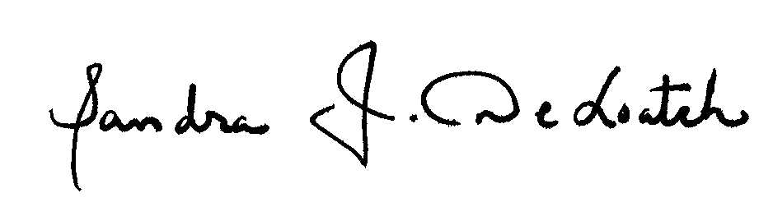
___________________________________________________________________ ______________________
Signature of Student (If applicable) Date

___________________________________________________________________ ___3/15/2011___________
Signature of the Principal Investigator/Faculty Mentor-Advisor Date

Human Subjects IRB Approval
Approve Disapprove Defer Revise Project Period: to

______________________________ ________________________________

Rowena Wilson, D.S.W. Paula R. D. Shaw

Chairman Director
Human Subjects Institutional Review Board Office of Sponsored Programs

Submit this form to:
Office of Sponsored Programs
700 Park Avenue | McDemmond Center for Applied Research (MCAR) | Suite 601 | Norfolk, VA 23504-8060
E-mail: osp@nsu.edu | Voice: .757.823.9053 | Fax: 757.823-2823

